1. -- Tutoring history (to store information of whether this student has received any tutoring in the first year)

* Number of Credits (to store the work load that the student did in first year )
* Credits to be taken (to store the work load that the student will be taking in second year)
* Degree (which qualification they are aiming for )
* Course & course Stats (which courses the student will take and what the statistics for passing that module are)
* NBT results
* School quantile (to see what type of resources the student may already be acquainted with. For example, Did the school have access to computers thus determining whether a student is computer literate or not)
* Tutorial/Practical/Workshop marks(To see how the student is faring so far)
* Accomodation(UCT Res’ have support structures in place were as private accommodation does not.)

1. 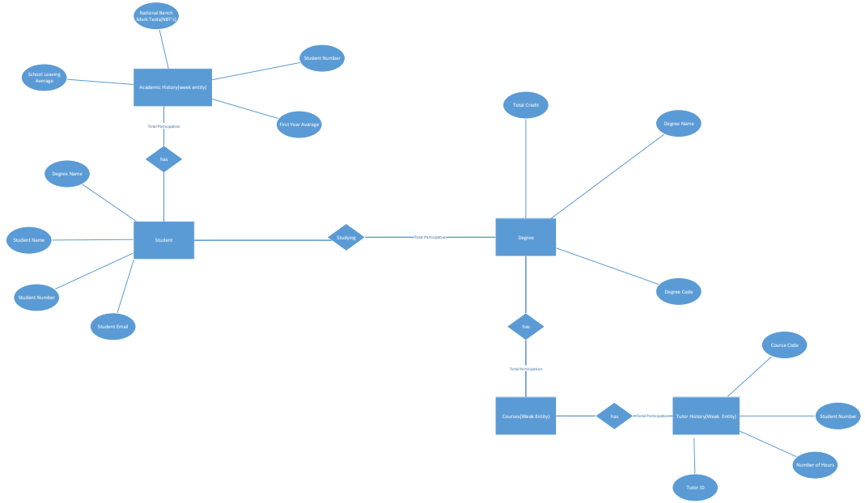
2. Student (DegreeName , StudentNumber, StudentName, StudentSurname, StudentEmail,)

Course (CourseCode, CourseConvener, CoursePassRate, CourseCredits,)

Degree (DegreeName, DegreeCode, TotalCredits)

TutorHistory (CourseCode, StudentNumber, NumberOfHours, TutorID)

AcademicHistory (StudentNumber, SchoolLeavingAverage, NBTaverage, FirstYearAverage)

1. AcademicHistory.StudentNumber
2. StudentNumber -> StudentName – StudentName is not a subset of StudentNumber. However, it is functionally dependent on StudentNumber
3. Adding the attribute StudentEmailAddressDomain to the Student relation scheme. this attribute would depend on StudentEmail, which is not the primary key, and thus our attributes would not depend on the ‘whole key’, thus voiding the conditions of 2nd normal form
4. Adding the attribute CourseLecturer , which would be dependent on the Course Convener(it is their choice who teaches the course). 2nd normal form is valid , and the table database is not in 3rd normal form.
5. Select a.StudentNumber, a. StudentEmail, b.FirstYearAverage from Student a inner join AcademicHistory b a.StudentNumber=b.StudentNumber where SchoolLeavingAverage>FirstYearAverage and FirstYearAverage>50. – It will show which students are performing poorer at varsity as compared to matric , provided they passed first year(i.e. average > 50)
6. Kakuwaezi Meriam – Named the foreign Key(q4), and gave the non-trivial functional dependency(q5)

Mahlangu Siphosakhe - Derived the ER model(q2) and outlined the additional information(q1)

Mavodze Jabulani– Derived the ER model(q2) , and gave the relation scheme(q3)

Mulovhedzi Muwanwa – Gave the SQL statement to generate the view of the data(q8) and gave examples for q6 and q7

Ramatlou Neo – Outlined the additional information(q1), and Gave the relation scheme(q3)